**Ans:- POLAND**

**In 1980: Poland had highest fertility rate:**

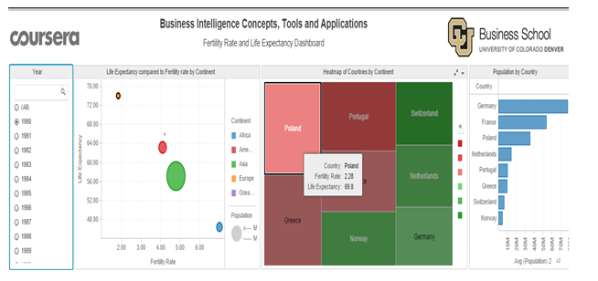

**In 2007: Poland has lowest fertility rate:**

